R u l I n g s A b o u t I ’ t I k a a f

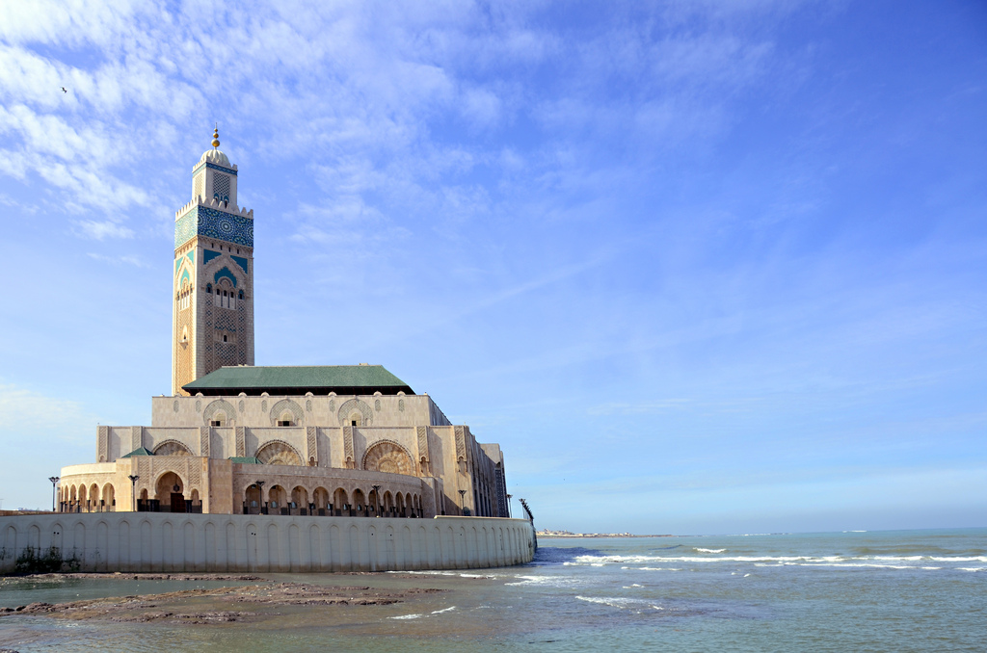
Rulings About I'tikaaf


E-Book
Sheikh | Muhammed Salih Al-Munajjid

| Rulings About I’tikaaf

Introduction
All praise is due to Allaah the most High, the Forgiving, and prayers and blessings be upon His chosen Prophet and his family and Companions.

To proceed:
Allaah the Almighty made some days and nights better than others. Every season of virtue brings with it a certain form of worshipping Allaah and a type of mercy from Allaah the Almighty. The successful person takes advantage of the hours, days and months of these seasons of virtue by worshipping his Lord through various acts of worship. This is so that he may be included in Allaah's mercy and saved from the torment of Hellfire.

One of the greatest virtuous deeds in the last ten days of Ramadhaan is I’tikaaf.

Allaah mentioned in the verses of fasting, (what means): {and do not haverelations with themas long as you are fasting for worship in the mosques.} [Qur’aan: 2:187]

He commanded us to purify mosques for His sake. Allaah Says (what means): {purify My House for those who perform Tawaaf, and those who are staying there for worship and those who bow andprostrate in prayer.} [Qur'aan: 2:125].

When the last ten days of Ramadhaan came, the Prophet, sallallaahu 'alayhi wa sallam, “tightened his lower garment”, abstained from relations with women “and woke his family to pray”. He would not leave out any of his family who were able to pray. “He would stay up at night” praying, supplicating and reciting the Qur'aan. “He would strive” to worship more than usual and worked hard at worshipping more than normal and he would perform I’tikaaf in the mosque, worshipping his Lord.

I’tikaaf means remaining in the mosque and residing there with the intention of worship and drawing closer to Allaah.

The Honorable Shaykh Ibn Baaz, may Allaah have mercy on him, said: “‘ I’tikaaf means staying in the mosque to worship Allaah for a long or short period of time as there is no proof that restricts it to a day or two or more than that.'”
The purpose of I’tikaaf is for the heart to be purely attached to Allaah the Almighty and to be cut off from preoccupation with His creation, by being preoccupied with Allaah alone. So the person's concerns and thoughts are turned entirely to the remembrance of Allaah and striving to gain Allaah's pleasure and to be closer to Him.
"The stronger is a person's knowledge, love and attachment to Allaah, it grants the person a devotion to Allaah in all circumstances.
The Prophet, sallallaahu 'alayhi wa sallam, used to engage in I’tikaaf (seclusion for prayers) in the mosque during the last ten nights of Ramadhaan till he passed away, then his wives followed this practice after him.

I’tikaaf is one of the least practiced Sunan among people.
Ibn Shihaab Az-Zuhri, may Allaah have mercy on him, said:

"How odd it is that the Muslims have abandoned I’tikaaf, despite the fact that the Prophet, sallallaahu 'alayhi wa sallam, never stopped it since he came to Madeenah until Allaah Almighty took his soul".
This form of worship includes many virtues and meanings which are as follows:
- Being pleased with Allaah, being alone with Him and being able to approach Him.
- It inculcates asceticism in a person and teaches them to abstain from a self-indulgent worldly existence and gives one patience with regards to the sacrificing the pleasure and comfort of sleeping on cozy mattresses. The person learns to stay away from pleasures, instead, approaching Allaah and worshipping Him through different forms of worship.
- Psychological reassurance through reading the Qur'aan and completing it, true repentance, praying at night and getting accustomed to it, occupying your time with beneficial activities, purifying your heart, devoting it to Allaah the Almighty and reviving it with remembrance.
- Seeking out the night of Qadr and taking advantage of it. This is the most cherished thing a person can seek.
- Protecting the heart from the consequences of excessive speech, food and drink, marriage and social interaction.

The process of I’tikaaf requires
- The person in seclusion should be mature; the I’tikaaf of a child is invalid.
- To be purified from the major impurities (Janaabah i.e., sexual impurity, menses and postpartum bleeding).
- To be cut off from purely worldly matters, such as accumulating wealth, trade, occupations and the pleasure of marriage and so on.
- I’tikaaf should take place in a mosque that holds congregational prayers in order to prevent abandoning Friday prayers and congregational prayers. Seclusion from these is unequivocally forbidden.

The place and time of I’tikaaf
The place:
Mosques vary in virtue, so priority is given to the mosque with the greatest reward and the most value which is the Sacred House (in Makkah). Every prayer there is worth a hundred thousand prayers. Then follows the mosque of the Prophet, sallallaahu 'alayhi wa sallam, where each prayer is worth a thousand prayers and then Al-Aqsa mosque. The most complete I’tikaaf is performed in these three mosques.
As for other congregational mosques they are all valid for I’tikaaf, Allaah Says (what means): {aslong as you are staying for worship in the mosques.} [Qur’aan: 2:187].
The standard differentiation between them is based on several things, including:
- How old the mosque is: Allaah Says (what means): {a mosque founded on righteousness from thefirst day is more worthy for you to stand in.} [Qur’aan: 9:108]
- -The mosque which has the largest number of people: The Prophet, sallallaahu 'alayhi wa sallam, said: “A man’s prayer with another man is better than his prayer alone and a man’s prayer with two others is better than his prayer with one man and the more people there are the more beloved is it to Allaah”.
- The mosque where the heart is more humbled: As the purpose of I’tikaaf is to be cut off from all but worship and obedience and devoting one's heart to Allaah, the secluded person must take into consideration choosing a convenient mosque where he finds righteousness and tranquility of the heart, even if it is not in the Haramayn (the two sacred mosques). So on this basis, the best mosque for the person performing I’tikaaf is the mosque that facilitates humbleness and where his heart is humbled more, like a secluded place of I’tikaaf free from disturbances and the presence of an Imaam whose recitation and sermons influence people.
The rooms in the mosque with doors that open into the mosque have the same ruling as the mosque.

So, it is permissible to perform I’tikaaf there, because they are a part of the mosque. However if these rooms are built on the border of the mosque the I’tikaaf is not valid.

It is permitted for someone performing I’tikaaf to reserve a place in the mosque like a room or corner or such, so as not to disturb the prayer.

Also, it is permitted for him to sit in any place that has the same ruling as the mosque like the mosque's courtyard and so on.

It is permissible to perform I’tikaaf at any time in Ramadhaan and at any other time. It is not restricted to a specific time, instead, it is desirable at all times, and is even better when fasting. Whoever vows to perform I’tikaaf is obligated to do so.

The best type of I’tikaaf is the period of the last ten days (of Ramadhaan), because it is what the Prophet, sallallaahu 'alayhi wa sallam, did. If the person cannot perform I’tikaaf during all the last ten days, then he can perform it for as long as he is able to even if it is one night.

Time of I’tikaaf
Whoever wants to perform I’tikaaf during all the last ten days must enter his place of I’tikaaf before the sunset of the twentieth day shortly before the beginning of the night of the twenty-first. This is as the majority of scholars say, due to the Hadeeth that the Prophet, sallallaahu 'alayhi wa sallam, said: “Whoever wants to engage in I’tikaaf with me so he should perform I’tikaaf in the last ten days”. He then leaves aftersunset on the last day of Ramadhaan whether it is twenty-nine or thirty days.

If the night is the night of doubt he waits until it is proved that it is the night of Fitr. If the news comes that it is the night of Fitr he leaves as soon as he knows that it is the night of ‘Eed.

Preparing mosques for I’tikaaf by cleaning them, refreshing them with perfume and serving those who are engaged in I’tikaaf is one of the greatest acts of worship.

Some of the rulings concerning I’tikaaf :
- Occupying oneself with prayer, reciting Qur’aan, the remembrance of Allaah the Almighty, repentance, taking account of one’s actions and pondering and meditating.
- Avoiding excessive speech and actions that do not concern the person.
- Avoiding debates and foul speech as these are already forbidden, even more so during I’tikaaf.
- It is permissible to speak when necessary and to speak to others. Also, it is acceptable to carry out permissible actions.
- It is acceptable to perform I’tikaaf with a friend or relative, staying away from useless speech and things that distract a person from the purpose of I’tikaaf.
- The person performing I’tikaaf must abide by the rulings concerning mosques in general, such as lowering one’s voice, avoidance of raising one’s voice, selling and announcing a search for lost items. The person must also pray Tahiyyat Al-Masjid (prayer on entering the mosque) when he leaves the mosque for a prolonged period of time and returns, as opposed to leaving for a short time and returning which does not require the person to pray Tahiyyat Al-Masjid. It is permissible to charge mobile phones if necessary.
- It is better for the person to bring all that is needed along with them when performing I’tikaaf and their personal effects should not be paid for by other people, instead the person should pay for others.
- The person should try to decrease his food consumption thus making one more active and reducing visits to bathroom.

Some people abandon their jobs and obligations to perform I’tikaaf. This is wrong as it goes against and violates the conditions of an employment contract, which is forbidden. How can someone abandon an obligation to carry out an optional deed? Whoever leaves their occupation to perform I’tikaaf, he must stop the I’tikaaf and return to his occupation so as to make his earnings Halaal.

I’tikaaf is nullified by leaving the mosque without a genuine need for leaving. As for necessary reasons for leaving such as going to the bathroom, Ghusl (ritual bathing) of Janaabah and getting food when there is nobody else to bringit, these are things for which one is allowed to leave. However, the person must strive to find the nearest place possible. The general rule is that one performing I’tikaaf is not permitted to leave the mosque unless absolutely necessary and he must fulfill his needs in the shortest time possible and then return.

Note: Selling and buying is not permissible in the mosque, and so if the person would like to order food from a restaurant, he should make the call outside of the mosque and he can then receive the food in the mosque and pay for it there, as it is considered payment of debt. It has been reported in the Sunnah that debts have been paid inside the mosque.
The person performing I’tikaaf cannot visit the sick or attend Janaazah (funerals) during his I’tikaaf. He cannot respond to invitations or fulfill the needs of his family unless it is necessary and cannot leave for carrying out duties or his job.

The person can make the condition before starting I’tikaaf, of leaving the mosque for a reason that doesn’t oppose the purpose of I’tikaaf.

For instance, he can say: if something urgent occurs or if I become ill I will leave the mosque. The advantage of making this condition is that if it does happen, and the person leaves due to that reason, he is still considered in I’tikaaf and the reward continues.

If the person becomes mildly ill during I’tikaaf, in a way that does not prevent them from residing in the mosque, such as headache, toothache etc. and other symptoms that do not require bed rest, it is not permissible to leave the mosque. The person can take painkillers or medication in his place and thus in this case leaving invalidates the I’tikaaf.
If the person is extremely ill and cannot reside in the mosque because he is in need of bed rest, medical treatment and so on, he is permitted to leave the mosque and return after recovery to continue his I’tikaaf.
If a woman in I’tikaaf menstruates she must leave the mosque.
I’tikaaf is not invalidated by a wet dream, but the person must leave to bathe and then return to the mosque, as a person in the state of Janaabah (impurity) is not permitted to remain in the mosque. His I’tikaaf will not be cut off by leaving to bathe. It is also permissible to transfer to another mosque due to a necessary reason or the desire to gain more reward by transferring to a better mosque, such as the Haramayn (the two sacred mosques of Makkah and Madeenah).
I’tikaaf is not invalidated by being forced to leave, as is the case with the helpless Muslims whose mosques are being bombarded.
I’tikaaf of an employed person:
- It is recommended to take some time from your vacation to invest in righteous deeds by engaging in I’tikaaf.
- Making the condition of leaving the mosque to go to work is not valid as it goes against the purpose of I’tikaaf.
- It is not permissible to use electronic devices for work-related purposes and even more so if it is related to selling and buying, such as trading with shares and so on.
- It is not permissible to perform I’tikaaf if it affects the person’s work or work interests.
- The employee can perform I’tikaaf for a whole night starting from sunset to dawn (as some scholars say) and on the weekend there is the opportunity for more than that.

I’tikaaf for women
I’tikaaf is Sunnah for women also. The Mothers of the Believers, may Allaah be pleased with them, used to perform I’tikaaf with the Prophet, sallallaahu 'alayhi wa sallam, during his life and they engaged in I’tikaaf after his death. The Muslim woman who is keen on worship must perform I’tikaaf according to these conditions:
- Her husband or Waliyy must give his permission to perform it.
- The mosque should be convenient in terms of cover and protection.
- It should be a safe place, especially at night.
- There should be no neglect of her husband and children’s needs by her performing I’tikaaf.
- If he husband tells her to leave the place of I’tikaaf she must do so.
- She must be pure from menses, but if she does menstruate she must cut off her I’tikaaf and she will gain reward from Allaah the Almighty.
- Having sincere intentions with Allaah with no showing off.
Some of the advantages of I’tikaaf:
- Having sincere intentions with Allaah and making yourself accustomed to it, as during I’tikaaf the person is alone with Allaah.
- It trains the person to engage in worship, especially night prayers, reciting Qur'aan, seeking forgiveness and turning to Allaah.
- Strengthening your connection with Allaah and turning towards Him.
- Devoting the heart to Allaah and unifying thoughts. Also utilizing your thoughts in a way that is of benefit in the Hereafter. This is helpful when it comes to facing trials and calamities.
- Reviewing your actions and accounting for them, realizing points of neglect and fixing them, especially in terms of worship and steadfastness.
- Training oneself to utilize time in the most advantageous way instead of wasting it.
- Reviving this great Sunnah that many people have abandoned (i.e., the Sunnah of I’tikaaf).
- Training oneself to be patient and fighting one’s self against the pursuit of desires and the Shaytaan.
- Being mindful of purity, praying in the first row and always reaching Takbeerat Al-Ihraam (the opening Takbeer of prayer). Also, acquiring the blessing of worship with the companionship of others and following the footsteps of the righteous.
- With the worship of I’tikaaf there is a distinction between the lawful (Islamic) seclusion with Allaah and the seclusion of Christian monks in monasteries and the seclusion of the people of extremism and innovation in the wilderness and caves.
Some mistakes people engaged in I’tikaaf may make:
- Sleeping for most of the day and staying up at night without engaging in acts of worship, such that the person barely even acknowledges prayer times.
- Leaving the mosque for no reason.
- Overuse of handheld electronic devices, tablets and phones causing the heart and thoughts to diverge from the mosque and out to the worldly life –even if one is present physically in the mosque. Some people even undertake their work and run their business when they are in their place of I’tikaaf. There is no doubt that it is clearly contradictory to the meaning of I’tikaaf.
- Frequent prolonged meetings between people who are engaged in I’tikaaf and outside visitors (not related to worship). Also, the preoccupation with meaningless talk: combining seriousness with amusement, and committing Haraam by backbiting and lying. The person who is truly performing I’tikaaf safeguards his time by staying away from visitors who occupy him from seclusion with Allaah the Almighty.
- The extravagance of food brought to the mosque, dirtying the carpets in the mosque and harming the worshippers with bad odors.
- Some people who perform I’tikaaf think that applying perfume and keeping clean is contrary to the intent of I’tikaaf, so they remain in a condition that disturbs the slaves of Allaah. The Prophet, sallallaahu 'alayhi wa sallam, used to stick his head out of his place of I’tikaaf for 'Aai'shah, may Allaah be pleased with her, to comb his hair.
- Engaging in reading about and following events takes away valuable time from I’tikaaf and it is not in consonance with its purpose.
- Performing I’tikaaf with the intention of showing off or for any other motive goes against sincere devotion. The saying of the Prophet, sallallaahu 'alayhi wa sallam: “Is it righteousness that you seek?” is proof of his forbidding it. This includes the way people extravagantly bring numerous types of food to the mosque for the people performing I’tikaaf and all the services they offer them. It is more righteous for the people of faith to steer clear of this hotel-like I’tikaaf, leaving this to the ones who are new to this act of worship (to make it easy for them).
- A man who engages in I’tikaaf when his family or parents are in need of him is actually abandoning something obligatory in favor of a Sunnah and this is forbidden. It is a great sin for a person to hold back what is due to the ones whose provision is in his hand.

In conclusion
Ata Al-Khuraasaani, may Allaah have mercy on him, said: “A person engaged in I’tikaaf is like a slave who has thrown himself between the hands of the Lord and then he says: ‘My Lord I will not leave my place until You forgive me, my Lord I will not leave my place until You have mercy on me!’”

paaaap

Zaad Al-Ma‘aad.
Ibn Rajab, "Lataai'f Al-Ma‘arif".
Reported by Al-Bukhaari and Muslim.
Al-Albaani ruled it as Hasan (sound).
Fatawa by Shaykh Abd Ar-rahmaan Al-Barraak.

