
Hajj
E-Book
Its Virtues and Benefits
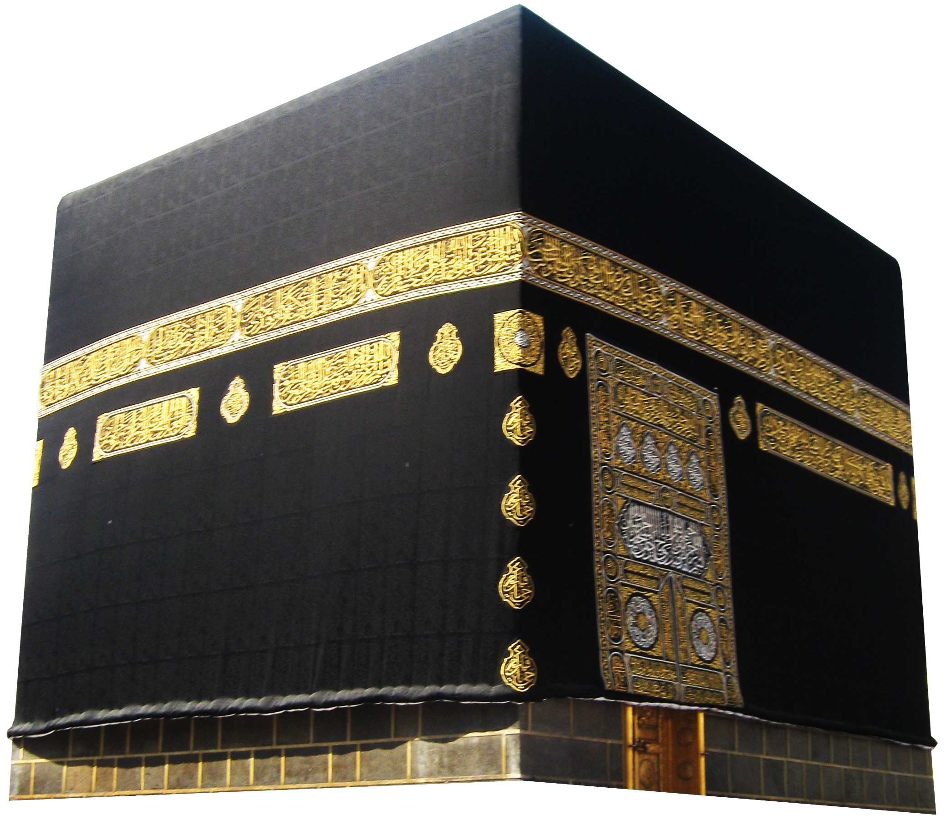

By.Sheikh | Muhammed Salih Al-Munajjid

﴿ﮬ ﮭ ﮮ ﮯ ﮰ ﮱ ﯓ ﯔ ﯕﯖ ﯗ ﯘ ﯙ ﯚ ﯛ ﯜ ﯝ﴾
[آل عمران:97].
Praise be to Allaah and peace and blessings be upon the Messenger of Allaah.
This is a brief discussion of Hajj – its virtues, benefits and a little about its rulings.
1. When Hajj was prescribed
According to the correct view, Hajj was made obligatory in 9AH, the year of the Delegations (al-Wufood), in which Chapter Aal ‘Imraan was revealed, in which Allaah Says (what means): {“And Hajj (pilgrimage to Makkah) to the House (Ka’bah) is a duty that mankind owes to Allaah, those who can afford the expenses (for one’s conveyance, provision and residence).”} ⁽⁾
2. The ruling on Hajj
Hajj is a Fareedah (obligatory duty), one of the pillars of Islaam. The evidence (Daleel) for this is the Aayah mentioned above, and there is also evidence in the Sunnah, which indicates the same thing.
Ibn ‘Umar, may Allaah be pleased with them both, said: "The Messenger of Allaah, sallallaahu 'alayhi wa sallam, said: “Islaam is built upon five (pillars): testifying that there is no god worthy of worship but Allaah and that Muhammad is the Messenger of Allaah, establishing regular prayer, paying Zakaah, Hajj and fasting Ramadhaan.” ⁽⁾.
3. Is Hajj obligatory straight away?
Yes, it should be done straight away. The evidence for this is the Aayah referred to above. This (doing things straight away) is the guiding principle concerning the commands of Sharee’ah. The evidence in the Sunnah which indicates this is as follows:
- Abu Hurayrah, may Allaah be pleased with him, said: "The Messenger of Allaah , sallallaahu 'alayhi wa sallam, gave a sermon (Khutbah) and said: 'O people, Allaah has enjoined Hajj upon you so do Hajj.'” ⁽⁾.
- Ibn ‘Abbaas, may Allaah be pleased with him, said: "The Messenger of Allaah , sallallaahu 'alayhi wa sallam, said: 'Whoever wants to go for Hajj, let him hasten to do it, because he may fall ill or some other problems may arise.' ⁽⁾.
According to a report reported by Ahmad: “Hasten to do Hajj –i.e., the obligatory Hajj – for none of you knows what may happen to him.”
These two reports strengthen one another ⁽⁾.
The Shaafi’is say that Hajj may be delayed, because the Prophet, sallallaahu 'alayhi wa sallam, delayed his Hajj until 10 AH.
But the answer to this is as follows:
- He only delayed it for one year, but they say it may be delayed indefinitely!
- He , sallallaahu 'alayhi wa sallam, wanted to purify the House (the Ka’bah) of the Mushrikeen (polytheists) and those who performed Hajj naked.
- He was kept busy with the delegations who had started to come to Madeenah one after another to announce their Islaam. ⁽⁾
4. It is obligatory to do Hajj once in one's lifetime
Abu Hurayrah, may Allaah be pleased with him, said: "The Messenger of Allaah, sallallaahu 'alayhi wa sallam, gave a sermon (Khutbah) and said: “ O people, Allaah has enjoined Hajj upon you so do Hajj.” A man said: 'Is it every year, O Messenger of Allaah?' He remained silent until the
man had said it three times, then he said: “If I say yes, it will become obligatory and you will not be able to do it.” Then he said: “Do not push me to tell you more than what I have left you with, for those who came before you were destroyed because they asked too many questions and argued with their Prophets. If I command you to do a thing, do as much of it as you can, and if I forbid you to do something, then avoid it.” ⁽⁾.
5. The virtues of Hajj
There are many narrations which speak of the virtues of Hajj, including the following:
a. From Abu Hurayrah, may Allaah be pleased with him, that the Messenger of Allaah, sallallaahu 'alayhi wa sallam, was asked which deed is best. He said: “Belief in Allaah and His Messenger.” He was asked: "Then what?" He said: “Jihaad for the sake of Allaah.” He was asked, then what? He said: “An accepted Hajj.” ⁽⁾.
An accepted Hajj means:
- It must be paid for with Halaal (lawful) money.
- One should keep away from evil, sin and unjust disputes during Hajj.
- One should observe all the rituals according to the Sunnah.
- One should not show off by doing Hajj; it should be purely and sincerely for thesake of Allaah.
- One should not follow it with acts of disobedience and sin.
- Abu Hurayrah, may Allaah be pleased with him, said: "I heard the Prophet , sallallaahu 'alayhi wa sallam, say: 'Whoever does Hajj for the sake of Allaah and does not have sexual relations (with his wife), commit sin, or dispute unjustly during the Hajj, will come back like the day his mother gave birth to him.'" ⁽⁾
- Abu Hurayrah, may Allaah be pleased with him, reported that the Prophet, sallallaahu 'alayhi wa sallam, said: “‘Umrah is an expiation for the time between it and the previous ‘Umrah, and an accepted Hajj has no less a reward than Paradise.” ⁽⁾.
- ‘Aa’ishah, the Mother of the Believers, may Allaah be pleased with her, said: 'I said, O Messenger of Allaah, can we not go out on campaigns and fight in Jihaad with you? He said: 'But the best and most beautiful of Jihaad is Hajj, an accepted pilgrimage.'" ‘Aa’ishah, may Allaah be pleased with her, said: 'I never stopped going for Hajj after I heard that from the Messenger of Allaah, sallallaahu 'alayhi wa sallam⁽⁾.
- ‘Amr ibn al-‘Aas, may Allaah be pleased with him, said: "The Messenger of Allaah , sallallaahu 'alayhi wa sallam, said: 'Hajj wipes out whatever (sins) came before it.'”⁽⁾.
- ‘Abd-Allaah ibn Mas’ood, may Allaah be pleased with him, said: "The Messenger of Allaah , sallallaahu 'alayhi wa sallam, said: 'Keep on doing Hajj and ‘Umrah, for they eliminate poverty and sin just as the bellows eliminate impurities from iron and gold and silver.' ⁽⁾ The Hadeeth was classed as Saheeh by al-Albaani, may Allaah have mercy on him, in al-Silsilah al-Saheehah, 1200).
- Ibn ‘Umar, may Allaah be pleased with them both, reported that the Prophet, sallallaahu 'alayhi wa sallam, said: “The one who fights for the sake of Allaah and the pilgrim who goes for Hajj or ‘Umrah are all guests of Allaah. He called them and they responded; they ask of Him and He will give them.” ⁽⁾.
6. The benefits of Hajj
Allaah Says (what means): {“That they may witness things that are of benefit to them”}⁽⁾.
The benefits are both worldly and religious (spiritual). With regard to the religious benefits, the one who goes for Hajj earns the pleasure of his Lord, and comes back with all his sins forgiven. He also earns the immense reward which he cannot earn anywhere else than in these places. One prayer in al-Masjid al-Haraam, for example, is equal to a hundred thousand prayers elsewhere, and Tawaaf (circumambulation) and Sa'y (running between Mount as-Safaa and al-Marwah) cannot be done anywhere except in these places.Other benefits include meeting other Muslims and discussing their circumstances, and meeting.
scholars, learning from them and asking them about one’s problems.
Worldly benefits include trade and business, and other kinds of earnings that have to do with Hajj.
7. The ruling on Hajj and its spiritual effects on a person
There are many virtues of the rituals of Hajj, and much wisdom behind them. Whoever is blessed with proper understanding of them is blessed with much goodness. For example:
- When a person travels to carry out the rituals of Hajj, he is reminded of his journey to Allaah and the Hereafter. When he travels, he leaves behind his dear friends, wife, children and homeland, and the journey to the Hereafter is like that.
- The one who goes on this journey equips himself with enough provision to help him reach the sacred land, so let him remember that for his journey to his Lord, he needs to have sufficient provision to help him get there safely. Concerning this, Allaah Says (what means): {“And take a provision (with you) for the journey, but the best provision is At- Taqwaa (piety, righteousness, etc.).”} ⁽⁾ .
- Travelling is a kind of torment, and the same is true of the journey to the Hereafter, only much more so. Ahead of man there is his dying, death, the grave, the gathering, the accounting, the scales and al-Siraat, followed by either Paradise or Hell. The blessed one will be the one whom Allaah saves.
- When the pilgrim puts on the two garments of his Ihraam, he cannot help but be reminded of the shroud in which he will be wrapped [after he dies]. This prompts him to give up disobedience and sin. Just as he has given up his regular clothing [for Hajj], so he has to give up sin. Just as he has put on two clean, white garments, he has to make his heart clean and white [pure], and keep his faculties clean and pure, uncontaminated by the stain of sin and disobedience.
- When he says “Labbayk Allaahumma labbayk” at the Meeqaat [station of entering Ihraam], he means that he has responded to his Lord, so how can he insist on still sinning and not respond to his Lord’s call to give it up? When he says “Labbayk Allaahumma labbayk”, he means, “I am responding to Your prohibition of it and this is the time I am giving it up.”
- When he gives up Haraam things during his Ihraam, and keeps himself busy with theTalbiyah and Thikr, this shows him how the Muslim should be. He trains himself to give up some things which in principle are Halaal, but Allaah has forbidden them to him at this time [during his Ihraam], so how can he violate the prohibitions of Allaah by doing things which are Haraam at all times and in all places?
- When he enters the Sacred House of Allaah, which Allaah has made a sanctuary for humankind, he remembers the sanctuary of the Day of Resurrection, which no one can reach without striving hard and making a concerted effort. The greatest thing which will keep a person safe on the Day of Resurrection is Tawheed (Islamic monotheism) and avoiding Shirk (associating others with Allaah). Concerning this, Allaah Says (what means): {“It is those who believe (in the Oneness of Allaah and worship none but Him Alone) and confuse not their Belief with Thulm (wrong, i.e. by worshipping others besides Allaah), for them (only) there is security and they are the guided.”} ⁽⁾. Kissing the Black Stone, which is the first ritual to be undertaken, teaches the visitor to honor the Sunnah and not to oppose the laws of Allaah with his feeble reasoning. He recognizes that there is wisdom and goodness behind the laws and rituals which Allaah has prescribed for humankind, and he trains himself to submit himself totally to his Lord, may He be exalted. Concerning this, ‘Umar, may Allaah be pleased with him, said, after he kissed the Black Stone: “I know that you are only a stone and that you can neither benefit nor harm. If I had not seen the Prophet, sallallaahu 'alayhi wa sallam, kiss you, I would not have kissed you.” ⁽⁾.
- When he does Tawaaf, he is reminded of his father Ibraaheem, may Allaah exalt his mention, who built the House to be a place of sanctuary for humankind and a place of safety, and that he called them to perform pilgrimage to this House. And our Prophet Muhammad, sallallaahu 'alayhi wa sallam, also called them to perform pilgrimage to this House. Moosa, Yoonus and ‘Eesa, may Allaah exalt their mention, also performed pilgrimage to this House. This House was a symbol and a meeting place for these Prophets; how could it be otherwise, when Allaah had commanded Ibraheem, may Allaah exalt his mention, to build it and venerate it?
- When he drinks the water of Zamzam, he is reminded of the blessing which Allaah has bestowed upon humankind in the form of this blessed water, from which millions of people have drunk throughout the long ages, but it has never dried up. He is encouraged to make Du’aa’ when he drinks it by the Hadeeth which has been reported from the Prophet, sallallaahu 'alayhi wa sallam: “The water of Zamzam is for whatever it is drunk for.” ⁽⁾. This is a Hasan Hadeeth; classed as Hasan by Ibn al-Qayyim, may Allaah have mercy on him, in Zaad al-Ma’aad, 4/320).
- When he does Sa’y, running between as-Safaa and al-Marwah, he is reminded of the trial endured by Haajar, the mother of Ismaa’eel and the wife of al-Khaleel [Ibraaheem], may Allaah exalt their mention, and how she ran back and forth between as-Safaa and al- Marwah, searching for water which would save her from what she was suffering, and especially so that she could give her little son – Ismaa’eel, may Allaah exalt his mention – water to drink. Since this woman was patient in the face of this adversity and turned to her Lord, this teaches man that doing this is better and more appropriate. When a man remembers the struggle and patience of this woman, it makes it easier for him to bear his own problems, and a woman who is of her own kind will find her problems easier to bear.
- The standing (Wuqoof) in ‘Arafaah reminds the pilgrim of the throngs of people on the Day of Gathering. If the pilgrim feels tired from being in a crowd of thousands, how will it be in the crowds of barefoot, naked, uncircumcised people, standing for fifty thousand years?
- When he throws the pebbles at the Jamaraat, the Muslim trains himself to obey Allaah unquestioningly. Even if he does not understand the reason and wisdom behind this throwing (Ramy), and cannot make the connection between rulings and their purpose, this is a manifestation of complete submission (‘Uboodiyyah) to Allaah.
- When he slaughters his sacrifice (Hady), he is reminded of the great event when our father Ibraaheem, may Allaah exalt his mention, submitted to the command of Allaah to sacrifice his only son Ismaa’eel, may Allaah exalt his mention, after he had grown up and become a help to him. He is also reminded that there is no room for emotions which go against the commands and prohibitions of Allaah. This teaches him to respond to what Allaah commands, as Ismaa’eel, may Allaah exalt his mention, said (what means): {“ ‘O my father! Do that which you are commanded. In shaa Allaah (if Allaah wills), you will find me of as-saabireen (the patient ones).’”} ⁽⁾.
- When he comes out of his Ihraam and things that had been forbidden to him once again become permissible, this teaches him about the consequences of patience and that after hardship comes ease. The one who responds to the call of Allaah will have joy and happiness, and this joy cannot be known by anyone except those who have tasted the sweetness of obedience, such as the joy felt by the one who fasts when he breaks his fast, or by the one who prays Qiyaam during the last part of the night, after he has finished praying.
- When he has finished performing all the rituals of Hajj as they were prescribed by Allaah and in the manner that Allaah loves, he has the hope that his Lord will forgive him all his sins, as the Prophet , sallallaahu 'alayhi wa sallam, promised in the Hadeeth: “Whoever does Hajj for the sake of Allaah and does not have sexual relations (with his wife), commit sin, or dispute unjustly during the Hajj, will come back like the day his mother gave birth to him. ⁽⁾ This invites him to start a new page in his life, free of sin.
- When he comes back to his wife and children, and experiences the joy of meeting them again, this reminds him of the greater joy of meeting them in Paradise. This also teaches him that the greatest loss is losing oneself and one’s family on the Day of Resurrection, as Allaah Says (what means): “The losers are those who will lose themselves and their families on the Day of Resurrection. Verily, that will be a manifest loss!” ⁽⁾.



We ask Allaah to help us to obey Him and to
reach His House and to do all that He has
enjoined upon us. May Allaah bless our Prophet
Muhammad, sallallaahu 'alayhi wa sallam.

⁽?⁾ [Qur'aan,3:97]
⁽?⁾ (Reported by Al-Bukhaari, 8; Muslim, 16)
⁽?⁾ (Reported by Muslim, 1337)
⁽?⁾ (Reported by Abu Daawood, 1732,without the phrase “because he may…”’ also reported by Ibn Maajah, 2883 and Ahmad,1836)
⁽?⁾ (See Irwaa’ al-Ghaleel by al Albaani, 4/168)
⁽?⁾ (See al-Sharh al-Mumti’ by Shaykh Ibn ‘Uthaymeen, 7/17, 18)
⁽?⁾ (Reported by Muslim, 1337)
⁽?⁾ (Reported by Al-Bukhaari, 26; Muslim, 83)
⁽?⁾ (Reported by Al-Bukhaari, 1449; Muslim, 1350)
⁽?⁾ (Reported by Al- Bukhaari, 1683; Muslim, 1349)
⁽?⁾ (Reported by Al-Bukhaari, 1762).
⁽?⁾ (Reported by Muslim, 121).
⁽?⁾ (Reported by at-Tirmithi, 810; an-Nasaa’i, 2631.
⁽?⁾ (Reported by Ibn Maajah, 2893. The Hadeeth is Hasan and was classed as such by Shaykh al-Albaani in al-Silsilat al-Saheehah, 1820)
⁽?⁾ ([Qur'aan, 22:28])
^{(?)} [Qur'aan, 2:197]
⁽?⁾ [Qur'aan, 6:81]
⁽?⁾ (Reported by Al-Bukhaari, 1520; Muslim, 1720)
⁽?⁾ (Reported by Ibn Maajah, 3062; Ahmad, 14435
⁽?⁾ [Qur'aan, 37:102]
⁽?⁾ (Reported by al-Bukhaari, 1449; Muslim, 1350)
⁽?⁾ [Qur'aan, 39:15]

